- Software Architecture & Requirements Specification
  - SRS Document
    - Will Include All the things except architecture
  - Software Architecture
    - High Level Architecture
- Architectural Diagrams ( Something like this )
  - 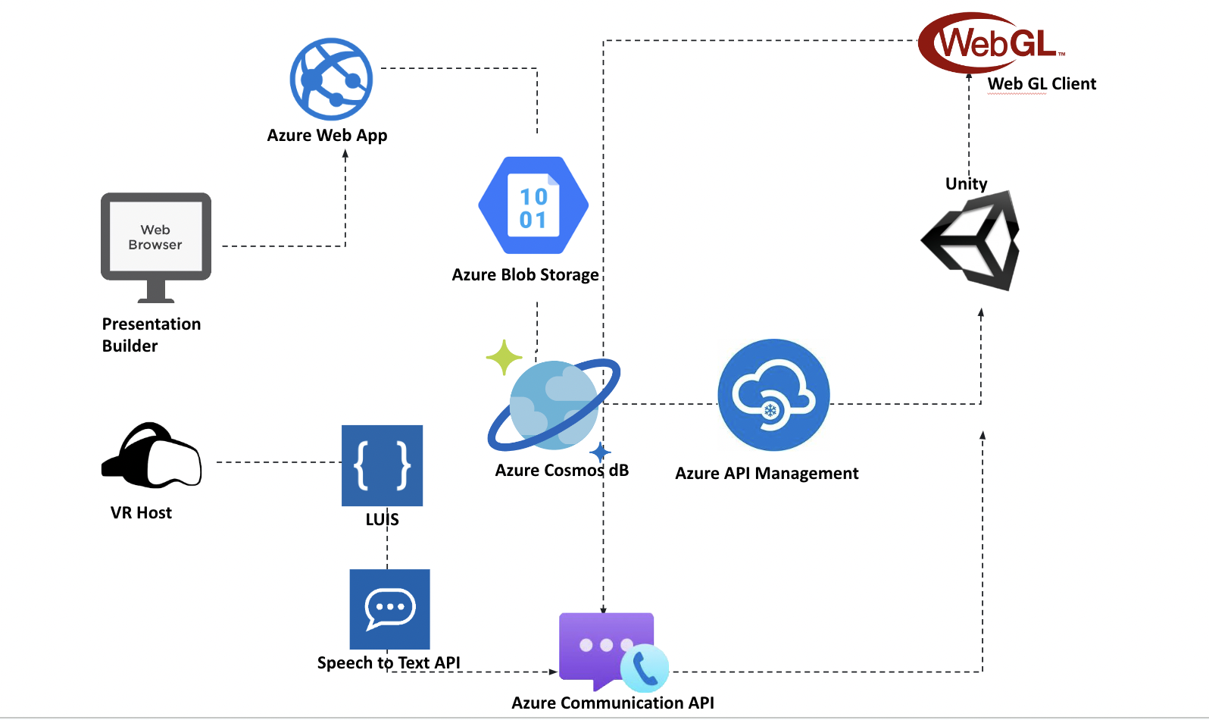
- System Component & Interaction
  - Different modules of a software system that work together to perform specific functions. For example database and player score data is combined to create the leaderboard systems.
- Data Flow & Communication
- Tech Stack
  - Unity
  - Firebase Realtime Database ( NoSql Cloud Database)
  - Firebase Analytics
    - Offers comprehensive app analytics to gain insights into user behavior, engagement, and app performance
  - Firebase Cloud Messaging (FCM):
    - FCM enables developers to send push notifications to users on various platforms, including Android, iOS, and the web
  - Playfab Content management
    - PlayFab provides a content management system (CMS) for managing in-game content such as levels, quests, leaderboards, and events
  - Content Management and Live Updates
    - PlayFab allows developers to make live updates to their games, delivering new content, bug fixes, or feature enhancements without requiring players to download updates.
- Scalability Considerations
  - How to scale to create more multiplayer session.
- Security & Data Privacy
  - How is user’s credentials protected ? What kind of authentication system are we using ? Two factor authentication ?
    - Game Level Architecture
      - Client Side Components
        - What are the client side components which will run on the local machine only ?
      - Server Side Components
        - What are the service side components that will run on the server explicitly ?
      - Networking
        - What kind of networking architecture are we using ?
        - Client-Server Networking: Client-server networking involves a dedicated game server that acts as a central authority, managing game logic and facilitating communication between clients
      - AI Components
        - How will Judge bots , user bots be handled during the gameplay ?
      - Persistence & Data Storage
      - External Services
        - What are the other external services that will be utilized in this game ? Like notification services and game analytics to see user engagement in the platform
      - Monetization
        - What kind of payment method will the game be using ? Is it gonna be distributed directly or any institution can sign up and pay for the game ?

- UI/UX Design Summary
  - Wireframe and Prototype( Figma Design project files )
  - Information Architecture ( Flowchart )
  - Visual Design
    - Color schemes
    - Typography
    - icons, and imagery
    - Visual Language
  - Interaction Design
    - UI Interaction
    - 2D Animation
    - Onboarding and Tutorials
    - Reward Systems & Achievements
    - Multiplayer Interactions
    - Accessibility Features
- MVP
  - Sharable Figma Prototype

